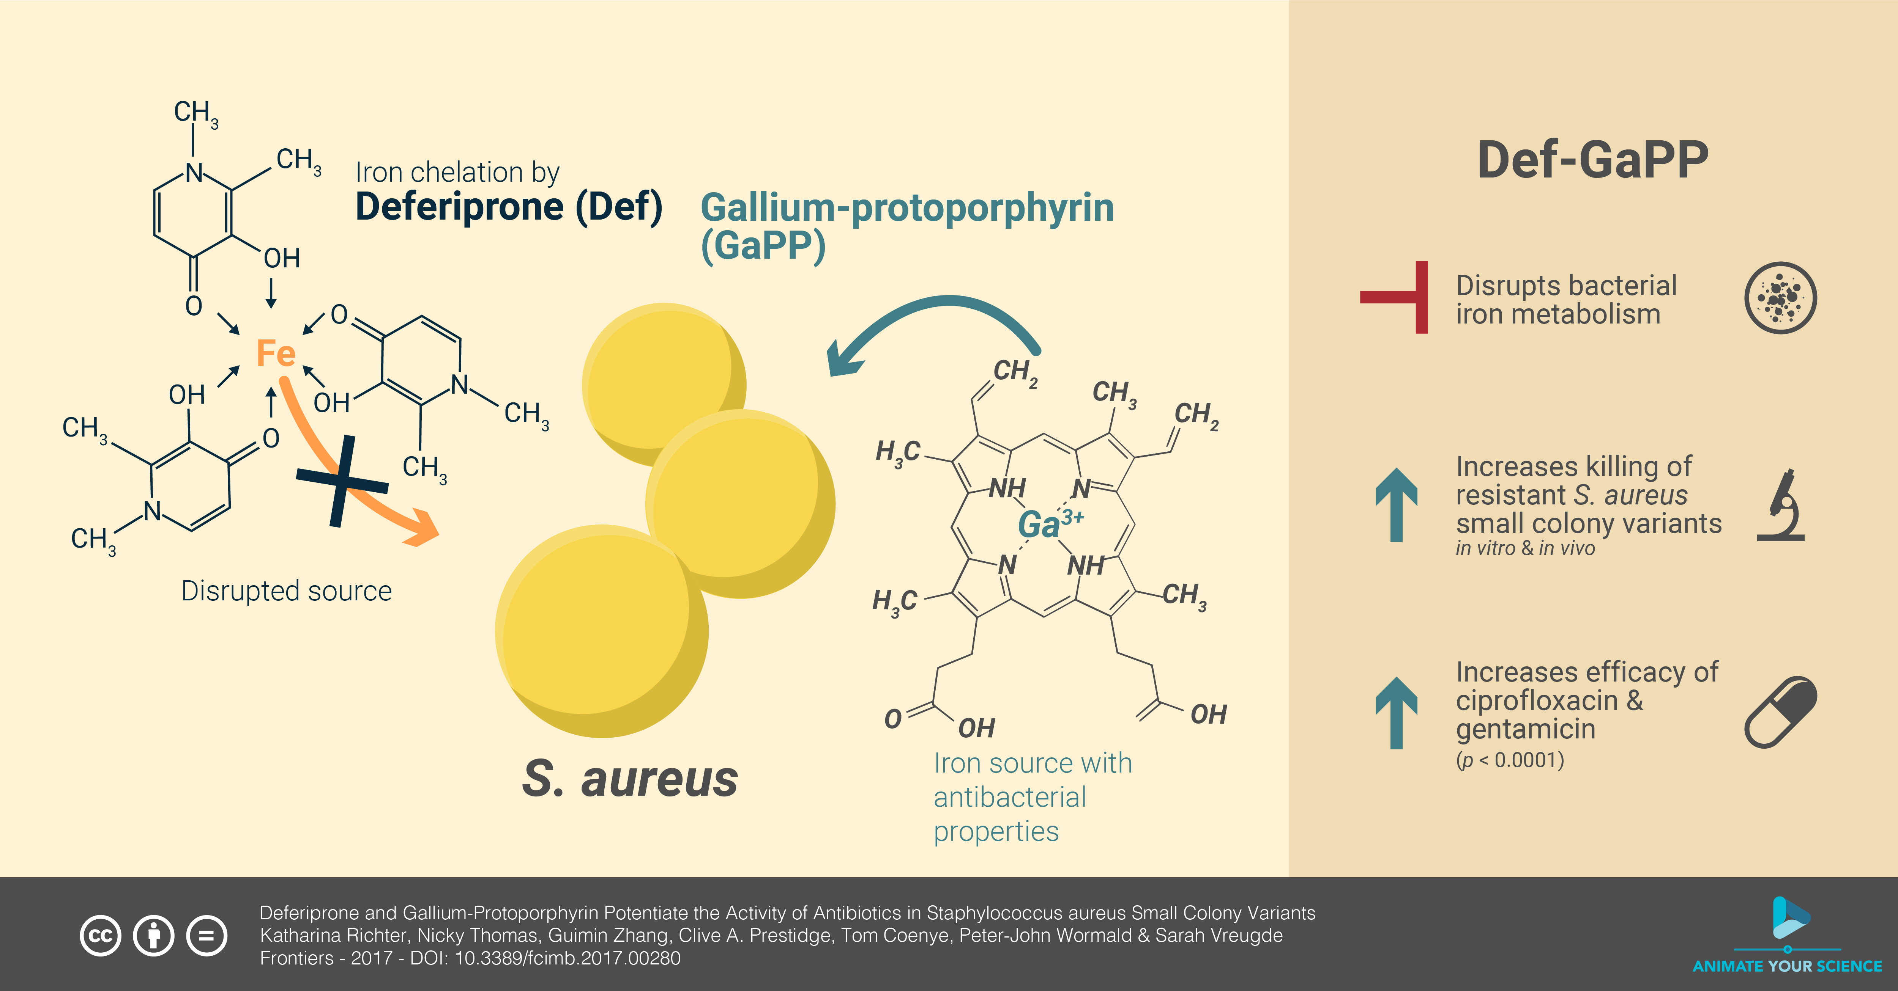
Image source (图片来源): https://en.wikipedia.org/wiki/Graphical_abstract#/media/File:Diagram_style.png
Image size (图片大小): 5000×2613
Example of a graphical summary (图形摘要的例子可见): https://www.elsevier.com/authors/tools-and-resources/graphical-abstract
Requirements for image captions:
Submit an image with a minimum size of 1328 x 531 pixels (width x height) and a minimum resolution of 300 dpi. If the submitted image is larger, use the same aspect ratio of 500 x 200.
Please use Times, Arial, Courier, or Symbol fonts, and use a large font size if possible, as images will be scaled down to fit the table of contents into a 200-pixel-high window.
Preferred file types are TIFF, EPS, PDF, or MS Office files. When submitting graphic abstract using MS Office Word or PowerPoint, we need to disable image compression in the advanced options (tutorial available at: https://support.microsoft.com/en-us/office/turn-off-picture-compression-81a6b603-0266-4451-b08e-fc1bf58da658).
图片摘要的要求：
提供尺寸至少为 1328 x 531 像素（宽 x 高），分辨率至少为 300 dpi 的图片。如果提交的图片尺寸更大，使用相同的宽高比500 x 200。
字体请使用 Times、Arial、Courier 或 Symbol 字体，并尽可能使用大号字体，因为为了使目录适应 200 像素高的窗口，图像将被缩小。
首选文件类型为 TIFF、EPS、PDF 或 MS Office 文件。使用MS Office Word或者Powerpoint提交图形摘要时需要关闭高级选项中图片压缩（教程可见：https://support.microsoft.com/en-us/office/turn-off-picture-compression-81a6b603-0266-4451-b08e-fc1bf58da658）

